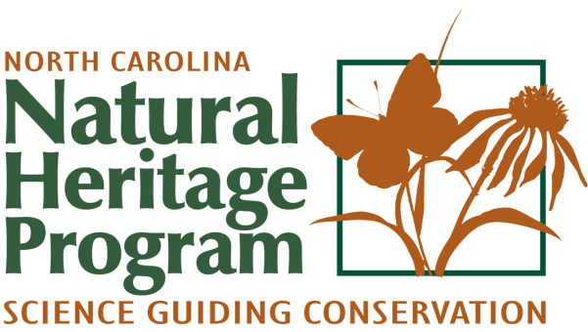

Please submit this form by email: natural.heritage@ncdcr.gov
Or mail:
N.C. Natural Heritage Program
Rare Animal Form
1651 Mail Service Center
Raleigh NC 27699-1651

Rare Animal Form Date submitted ___________

Contact Information
Name
Agency/Affiliation
Street Address
City ST Zip Code
Phone
E-Mail Address

Observation Information
Scientific Name
Common Name
Survey Location | Latitude _____________ Longitude _____________ (in decimal degrees)
 | County ___________________ Landowner _____________________________
Date(s) of Observation:
Observer(s)

Observation Description:
- Exact Location (please provide a specific written description and also provide a shapefile, kmz file, or a map with site clearly marked)

- Type of Observation (sight records, vocal record, specimen, photograph, etc.)

- Number of Animals (include age and sex, if known)

- Behavior of Animals (singing, foraging, at nest, etc.)

- Habitat: (use NC NHP natural community name if known; describe dominant vegetation, maturity of vegetation, slope, aspect, etc.)

